­­

**Special Colloquium**

**Darkly Charged Dark Matter**

**Lisa Randall**  
Harvard University

**March 2, 2020**  
11:00 a.m.

**Ramsey Auditorium**

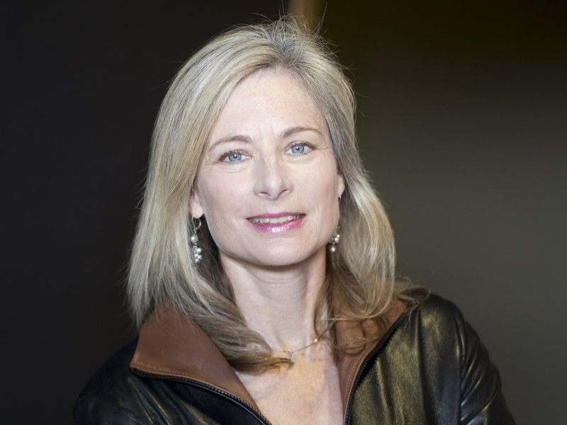

Generally physicists assume that dark matter is a single particle with no interactions in its own sector. We demonstrate that these assumptions are not necessarily true. In particular we show that dark matter can be charged under its own force, even if as light as the weak scale. We furthermore consider the possibility that only a fraction of the dark matter is charged, and can even form a disk inside the Milky Way.